**Table S1.** Internal validation data estimation performance of amikacin pharmacokinetic parameters

|  |  |  |  |  |  |  |  |  |  |  |  |  |
| --- | --- | --- | --- | --- | --- | --- | --- | --- | --- | --- | --- | --- |
| **Sampling time** |  | **Peak** | |  | **Trough** | |  | **Peak and trough** | |  | **Every 1h** | |
|  | **MPE** | **RMSE** |  | **MPE** | **RMSE** |  | **MPE** | **RMSE** |  | **MPE** | **RMSE** |
| **Single dose** |  |  |  |  |  |  |  |  |  |  |  |  |
| CLslope |  | 8.32 | 0.30 |  | 2.97 | 0.14 |  | 2.94 | 0.12 |  | 1.37 | 0.06 |
| CLnr (mL/min/kg) |  | 3.00 | 0.01 |  | 3.02 | 0.01 |  | 3.02 | 0.01 |  | 2.90 | 0.01 |
| Vnr (L/kg) |  | 1.70 | 0.04 |  | 2.77 | 0.08 |  | 1.99 | 0.04 |  | 1.14 | 0.03 |
| **Steady-state** |  |  |  |  |  |  |  |  |  |  |  |  |
| CLslope |  | 3.80 | 0.21 |  | 1.37 | 0.13 |  | 1.44 | 0.09 |  | 0.95 | 0.05 |
| CLnr (mL/min/kg) |  | 3.06 | 0.01 |  | 3.07 | 0.01 |  | 3.09 | 0.01 |  | 3.05 | 0.01 |
| Vnr (L/kg) |  | 1.00 | 0.08 |  | 1.98 | 0.08 |  | 1.59 | 0.06 |  | 0.91 | 0.04 |

**Abbreviations:** CLslope, rate of change in drug clearance with respect to creatinine clearance; CLnr, clearance independent of renal function; Vnr, distribution volume independent of renal function.

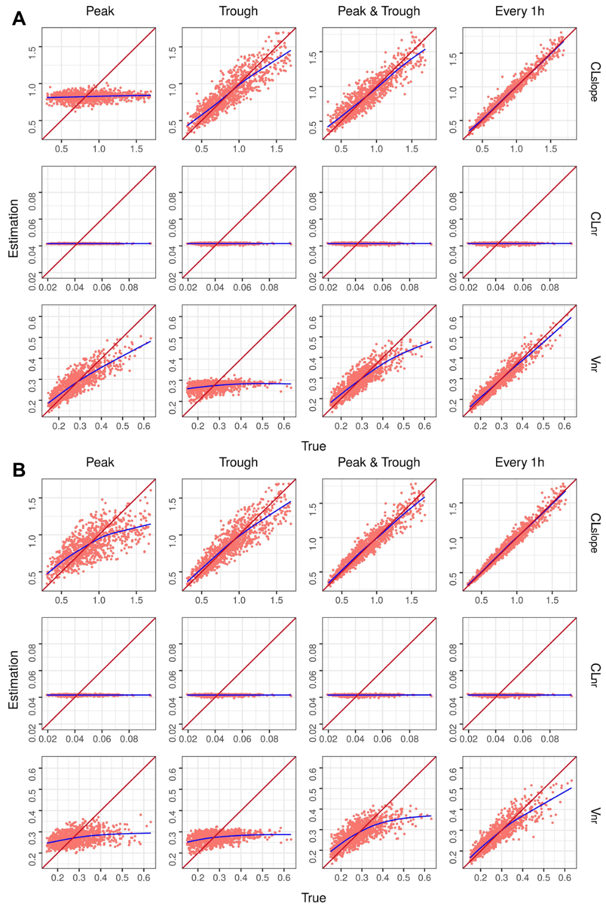

**Figure** **S1**. Graphs representing the amikacin parameters estimated versus true values in each internal validation scenario. The identity line is shown in red and a trend line in blue has been drawn for each model. (**A**) Signal dose. (**B**) Steady state. **Abbreviations**: CLslope, rate of change in drug clearance with respect to creatinine clearance; CLnr, clearance independent of renal function; Vnr, distribution volume independent of renal function.

**Table S2.** Internal validation data estimation performance of vancomycin pharmacokinetic parameters

|  |  |  |  |  |  |  |  |  |  |  |  |  |
| --- | --- | --- | --- | --- | --- | --- | --- | --- | --- | --- | --- | --- |
| **Sampling time** |  | **Peak** | |  | **Trough** | |  | **Peak and trough** | |  | **Every 1h** | |
|  | **MPE** | **RMSE** |  | **MPE** | **RMSE** |  | **MPE** | **RMSE** |  | **MPE** | **RMSE** |
| **Single dose** |  |  |  |  |  |  |  |  |  |  |  |  |
| CLslope |  | 4.21 | 0.25 |  | 3.34 | 0.16 |  | 3.57 | 0.16 |  | 2.96 | 0.12 |
| CLnr (mL/min/kg) |  | 1.07 | 0.01 |  | 1.09 | 0.01 |  | 1.10 | 0.01 |  | 1.11 | 0.01 |
| Vnr (L/kg) |  | 0.69 | 0.04 |  | 1.93 | 0.04 |  | 0.51 | 0.04 |  | 0.14 | 0.03 |
| k12 (1/h) |  | 4.28 | 0.19 |  | 6.08 | 0.22 |  | 4.01 | 0.19 |  | 4.42 | 0.19 |
| k21 (1/h) |  | 3.37 | 0.11 |  | 2.28 | 0.12 |  | 2.93 | 0.11 |  | 1.45 | 0.09 |
| **Steady-state** |  |  |  |  |  |  |  |  |  |  |  |  |
| CLslope |  | 0.47 | 0.15 |  | 1.78 | 0.11 |  | 0.53 | 0.08 |  | 0.68 | 0.04 |
| CLnr (mL/min/kg) |  | 1.11 | 0.01 |  | 1.16 | 0.01 |  | 1.10 | 0.01 |  | 1.21 | 0.01 |
| Vnr (L/kg) |  | 1.58 | 0.04 |  | 1.51 | 0.04 |  | 1.08 | 0.04 |  | 0.42 | 0.04 |
| k12 (1/h) |  | 5.43 | 0.22 |  | 5.58 | 0.22 |  | 4.56 | 0.20 |  | 4.53 | 0.20 |
| k21 (1/h) |  | 3.05 | 0.12 |  | 2.91 | 0.12 |  | 3.17 | 0.12 |  | 2.64 | 0.10 |

**Abbreviations** CLslope, rate of change in drug clearance with respect to creatinine clearance; CLnr, clearance independent of renal function; Vnr, distribution volume independent of renal function; k12, first-order transfer rate constant from the central compartment to peripheral compartment; k21, first-order transfer rate constant from the peripheral compartment to central compartment.

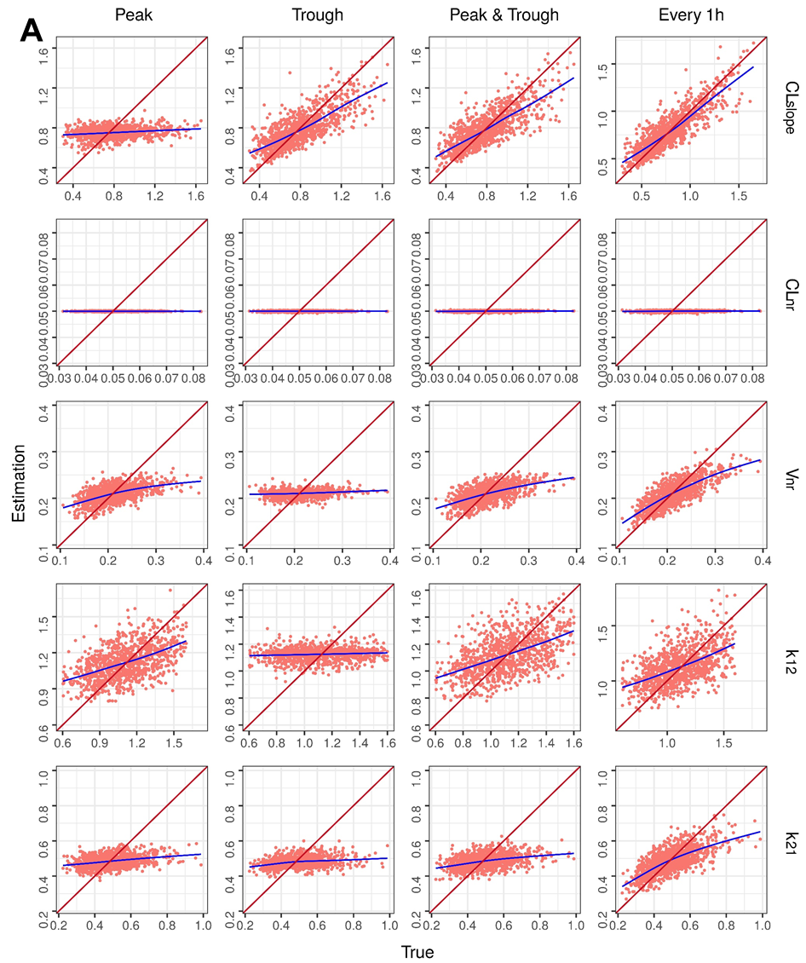

**Figure** **S2**. *Cont*.

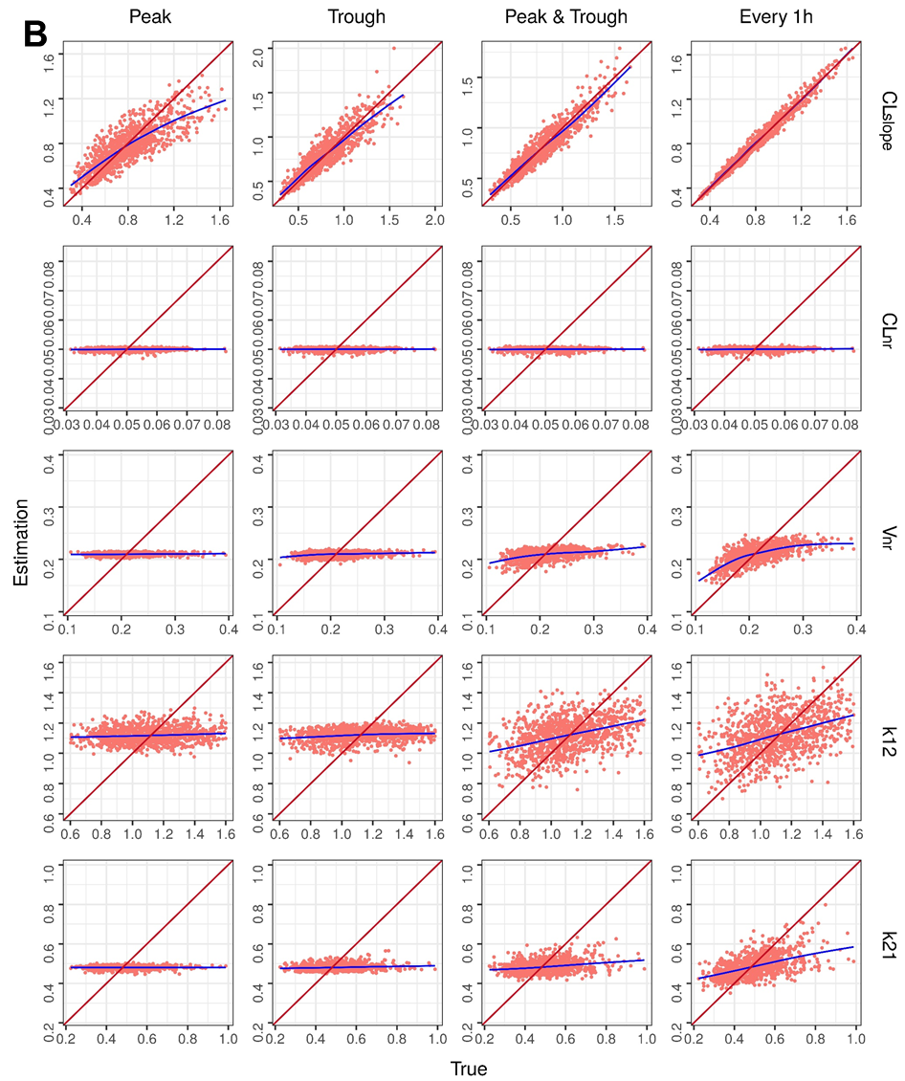

**Figure S2.** Graphs representing the vancomycin parameters estimated versus true values in each internal validation scenario. The identity line is shown in red and a trend line in blue has been drawn for each model. (**A**) Signal dose. (**B**) Steady state. **Abbreviations** CLslope, rate of change in drug clearance with respect to creatinine clearance; CLnr, clearance independent of renal function; Vnr, distribution volume independent of renal function; k12, first-order transfer rate constant from the central compartment to peripheral compartment; k21, first-order transfer rate constant from the peripheral compartment to central compartment.

**Table S3.** Internal validation data estimation performance of theophylline pharmacokinetic parameters

|  |  |  |  |  |  |  |  |  |  |  |  |  |
| --- | --- | --- | --- | --- | --- | --- | --- | --- | --- | --- | --- | --- |
| **Sampling time** |  | **Peak** | |  | **Trough** | |  | **Peak and trough** | |  | **Every 1h** | |
|  | **MPE** | **RMSE** |  | **MPE** | **RMSE** |  | **MPE** | **RMSE** |  | **MPE** | **RMSE** |
| **Single dose** |  |  |  |  |  |  |  |  |  |  |  |  |
| CLnr (mL/h/kg) |  | 1.53 | 5.82 |  | 1.43 | 5.23 |  | 1.25 | 5.30 |  | 1.22 | 4.62 |
| Vnr (L/kg) |  | 2.31 | 0.06 |  | 2.72 | 0.07 |  | 2.08 | 0.06 |  | 1.69 | 0.04 |
| **Steady-state** |  |  |  |  |  |  |  |  |  |  |  |  |
| CLnr (mL/h/kg) |  | 1.08 | 4.55 |  | 1.11 | 4.20 |  | 1.20 | 3.55 |  | 0.71 | 1.80 |
| Vnr (L/kg) |  | 2.45 | 0.07 |  | 2.47 | 0.07 |  | 2.33 | 0.07 |  | 2.15 | 0.07 |

**Abbreviations:** CLnr, clearance independent of renal function; Vnr, distribution volume independent of renal function.

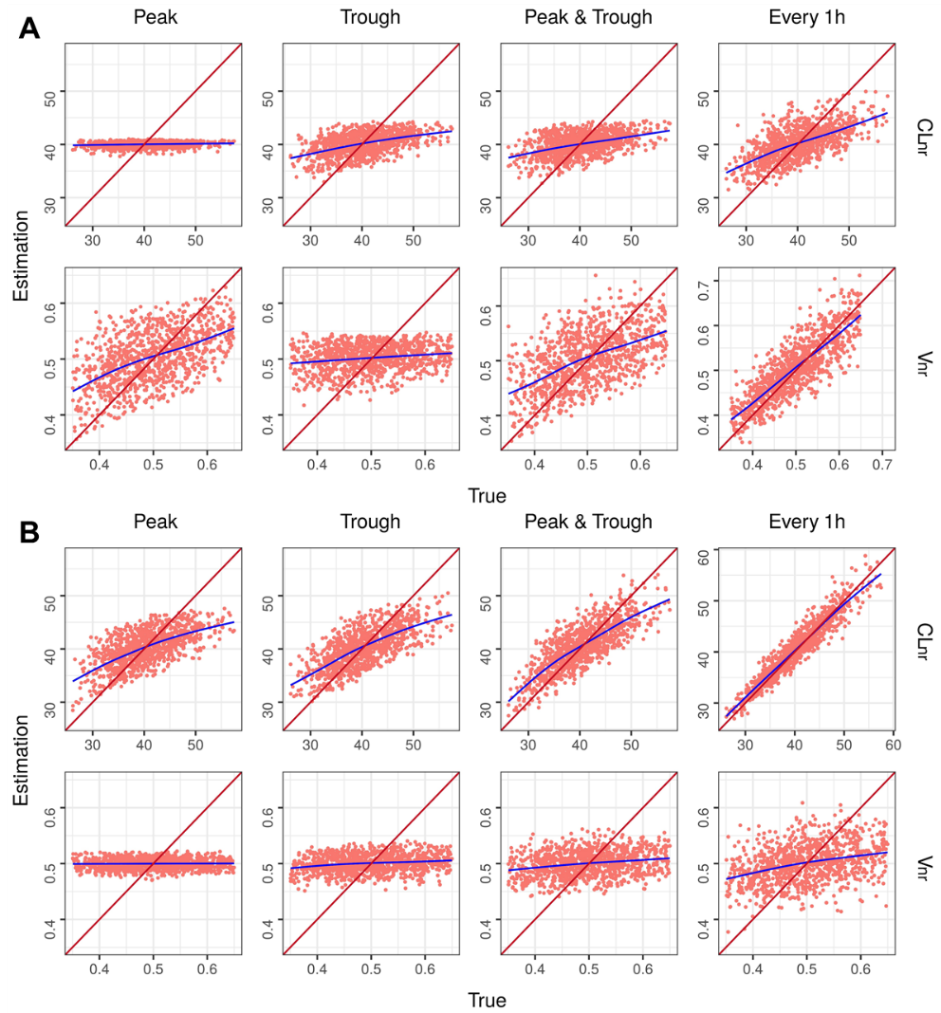

**Figure S3.** Graphs representing the theophylline parameters estimated versus true values in each internal validation scenario. The identity line is shown in red and a trend line in blue has been drawn for each model. (**A**) Signal dose. (**B**) Steady state. **Abbreviations:** CLnr, clearance independent of renal function; Vnr, distribution volume independent of renal function.

**Table S4.** Internal validation data estimation performance of phenytoin pharmacokinetic parameters

|  |  |  |  |  |  |  |  |  |  |  |  |  |
| --- | --- | --- | --- | --- | --- | --- | --- | --- | --- | --- | --- | --- |
| **Sampling time** |  | **Peak** | |  | **Trough** | |  | **Peak and trough** | |  | **Every 1h** | |
|  | **MPE** | **RMSE** |  | **MPE** | **RMSE** |  | **MPE** | **RMSE** |  | **MPE** | **RMSE** |
| **Single** **dose** |  |  |  |  |  |  |  |  |  |  |  |  |
| Vmax (mg/kg/d) |  | 3.31 | 135.33 |  | 3.34 | 134.71 |  | 3.42 | 134.69 |  | 3.55 | 132.14 |
| km (mcg/mL) |  | 10.25 | 2.04 |  | 10.10 | 2.03 |  | 10.07 | 2.04 |  | 9.73 | 2.02 |
| Vnr (L/kg) |  | 1.39 | 0.14 |  | 1.74 | 0.14 |  | 1.67 | 0.14 |  | 2.06 | 0.13 |
| **Steady**-**state** |  |  |  |  |  |  |  |  |  |  |  |  |
| Vmax (mg/kg/d) |  | -0.64 | 57.01 |  | -0.91 | 62.80 |  | -0.82 | 65.50 |  | -0.99 | 67.95 |
| km (mcg/mL) |  | 1.17 | 1.63 |  | 1.76 | 1.69 |  | 2.02 | 1.73 |  | 2.46 | 1.78 |
| Vnr (L/kg) |  | 0.78 | 0.11 |  | 0.71 | 0.12 |  | 1.21 | 0.12 |  | 1.30 | 0.13 |

**Abbreviations:** Vmax, maximum velocity; km, Michaelis constant; Vnr, distribution volume independent of renal function.

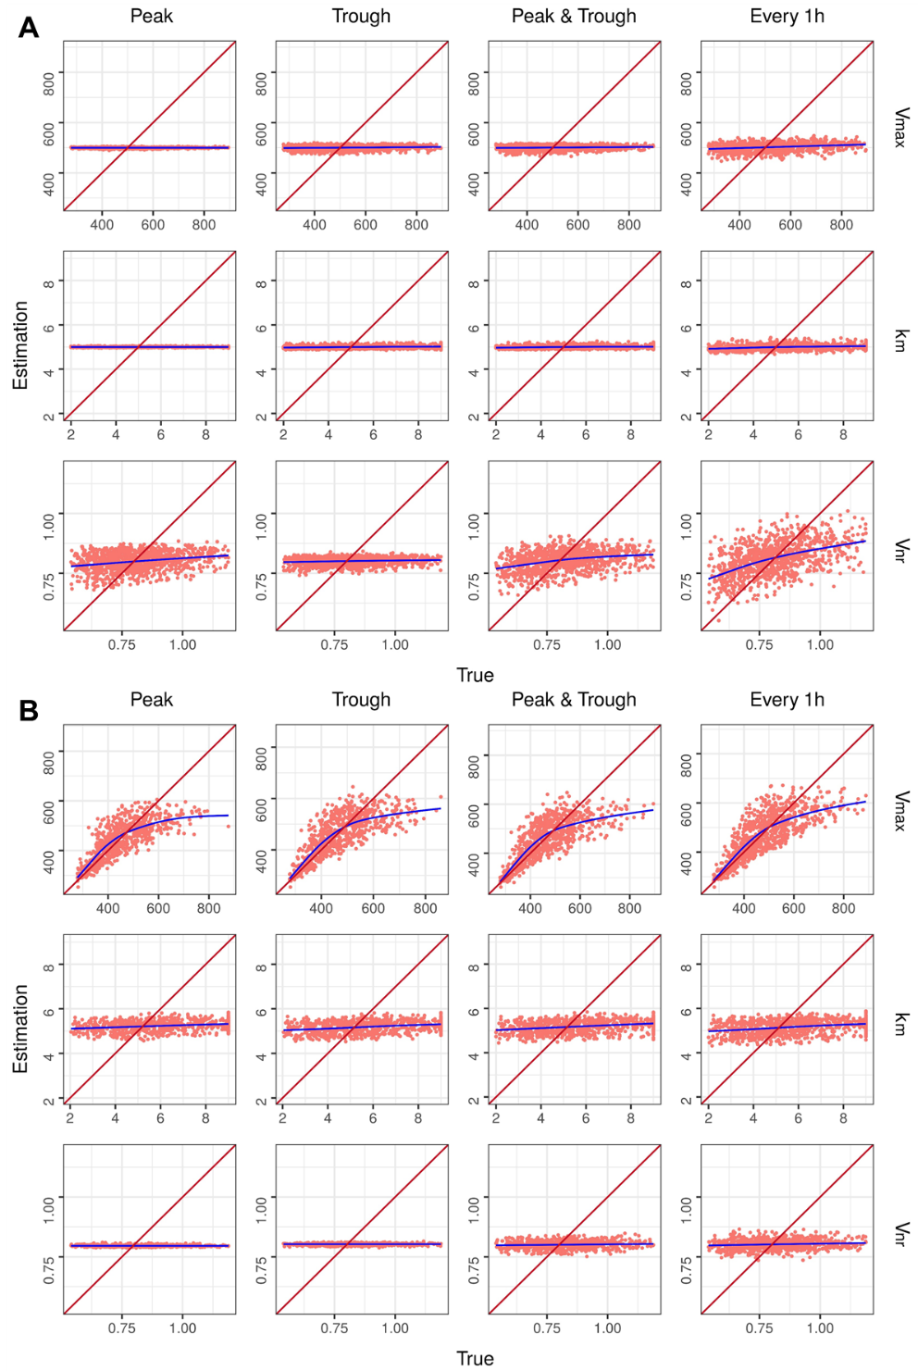

**Figure S4.** Graphs representing the phenytoin parameters estimated versus true values in each internal validation scenario. The identity line is shown in red and a trend line in blue has been drawn for each model. (**A**) Signal dose. (**B**) Steady state. **Abbreviations:** Vmax, maximum velocity; km, Michaelis constant; Vnr, distribution volume independent of renal function.